**Reading Lesson Plan**

Name: Gardner Length of lesson: 60 minutes

Students: Students in Thailand; age 18; mix gendered class

Reason(s) of lesson: To understand New Year celebrations in eight countries: China, Egypt, Germany, Great Britain, United States, Japan, India and Greece

Place and time: At the English-language classroom offered in the first period of November

Setting: Public school, daily class a few hours in the morning or afternoon

Available facilities: Large classroom that provides the individual desks grouped in five, a computer connected to the internet, a projector, a whiteboard and a marker

Main skill area(s): Reading, speaking and writing

ACTFL level: Pre-intermediate

Theme: New Year Celebrations around the World

Materials: Computer with PowerPoint, a large whiteboard and markers, pieces of paper, some crayons, a video about Brief History of New Year Celebrations around the World (https://www.youtube.com/watch?v=9kj4u92Z4Nw), a reading text about New Year Celebrations around the World, KWL worksheets and articles.

Objective(s): By the end of the lesson, students will be able to show understanding of New Year celebrations in eight countries that are China, Egypt, Germany, Great Britain, United States, Japan, India and Greece, use a passive form of Simple Present Tense (is/am/are + past participle), read an article and make a conclusion of the articles about New Year celebrations in different countries.

I assume that the students already know some of the vocabulary needed to understand the New Year Celebrations around the World, the passive form of Simple Present Tense and the interest in reading an article, expressing an idea and evaluating the article.

I anticipate that students will have problems with the pragmatic use of new vocabulary and the passive form of Simple Present Tense and some confusion or problems with the subject matter: New Year Celebrations around the World.

To solve or avoid the problems I plan to have students show understanding about the Brief History of New Year Celebrations around the World, make a conclusion of reading text into the KWL worksheet and work in a group to read and evaluate the article.

How I access the students is controlling and gathering feedback during the activities: KWL Reading and Jigsaw Reading (Students develop the text.).

|  |  |  |  |  |  |
| --- | --- | --- | --- | --- | --- |
| **Time** | **Lesson Stage** | **Procedures/Steps** | **Beliefs underlying your choices** | **Materials and Aids** | **Comments after teaching** |
| 10  minutes | **Pre-reading**   * Prediction * Motivation * Personalization * Vocabulary | Teacher shows the photos of New Year celebrations in different countries, posts them on the whiteboard and has students guess what the photos are about and what the lesson topic is.  Teacher turns on a video of Brief History of New Year Celebrations around the World and has students answer the questions: "What is the video mainly about?", "How many countries are mentioned about the New Year celebrations in the video?" and "How important is it? "  Ask students a question again: "How do you celebrate New Year Festival in your country?" If students say either *yes* or *no*, keep asking them to explain how it is celebrated and how it is important.  Teacher shows students some sentences from reading text on PowerPoint and asks them to try to deduce the meaning of the bold words from the context:   * *Ecuador celebrates a* ***unique*** *tradition on the last day of the year.* * *These* ***rituals*** *are the following: Twelve grapes: Each person eats twelve grapes before midnight, making a wish with each grape.* | Students will be more interested in New Year celebrations in eight countries around the world.    Students use the personal experience to the question: personalization.  Students understand the pragmatic use of new vocabulary and definitions found in the reading text. | Computer and projector with PowerPoint, some photos, a whiteboard and a marker  A video about Brief History of New Year Celebrations around the World *(https://www.youtube.com/watch?v=9kj4u92Z4Nw)* |  |
| 25 minutes | **During**   * Reading Schema * Reading for Comprehension | **KWL READING:**  Teacher divides students into a group of five, and there are eight groups.    Teacher gives the KWL reading worksheets consisting of three columns: column K is what students **know** about the topic, column W is what they **want** to know more and column L is what they **learn** from the lesson.  Tell students to spend 10 minutes discussing about what they know and what they want to know more about the New Year celebrations around the world, and complete the columns K and W.  Give each group an excerpt about the New Year celebrations in different countries. Each group gets a different excerpt.  Students read their excerpts, discuss and find out the answers for the questions in a group, and complete the column L: what you learn from the reading text.  Each group comes to present what the excerpt is about.  Teacher has each group write down the information given by the other groups into column L. | Students will be given a chance to read in a variety of ways: encouraging students to read for comprehension of what is being written in a text and practicing reading for a conclusion. | Reading text about New Year Celebrations around the World, excerpts and KWL reading worksheets. |  |
| 25 minutes | **Post-reading**   * Co-operative Reading * Lesson Wrapping-up | **JIGSAW READING:**  Teacher divides students into group of five which is called “Home Group” by counting 1-5 and gives each group an article about the New Year celebrations in different countries. Then, each group discusses and concludes about the given article.  Each member from each group has to make a new group called “Expert Group” with the students who count the same number. Then, each member has to share his article to other members in the expert group. The students can take note while listening.  Each member from the Expert Group goes back to the Home Group. Students share what they have learned from the Expert Group. Teacher gives each group a piece of paper, has each group make a mind mapping of New Year celebrations in each country and tells what the most favorite celebration is with some reasons. Every group comes in front of the class to present their work.  Teacher uses the discussion as a way making a conclusion of a lesson by asking students some questions: What is your most favourite New Year celebration? How does it interest you? | Students will discuss about a given topic in a group and summarize it from their own comprehension.  Students will exchange the information of what they have learnt and summarized to the others in a new group.  Students will share what they have learned and summarized making a mind mapping and make an evaluation for the most favorite article.  Students will be able to show their more understanding about the lesson. | Articles about New Year celebrations in different countries  Pieces of paper for taking note  Pieces of paper, crayons and pens |  |

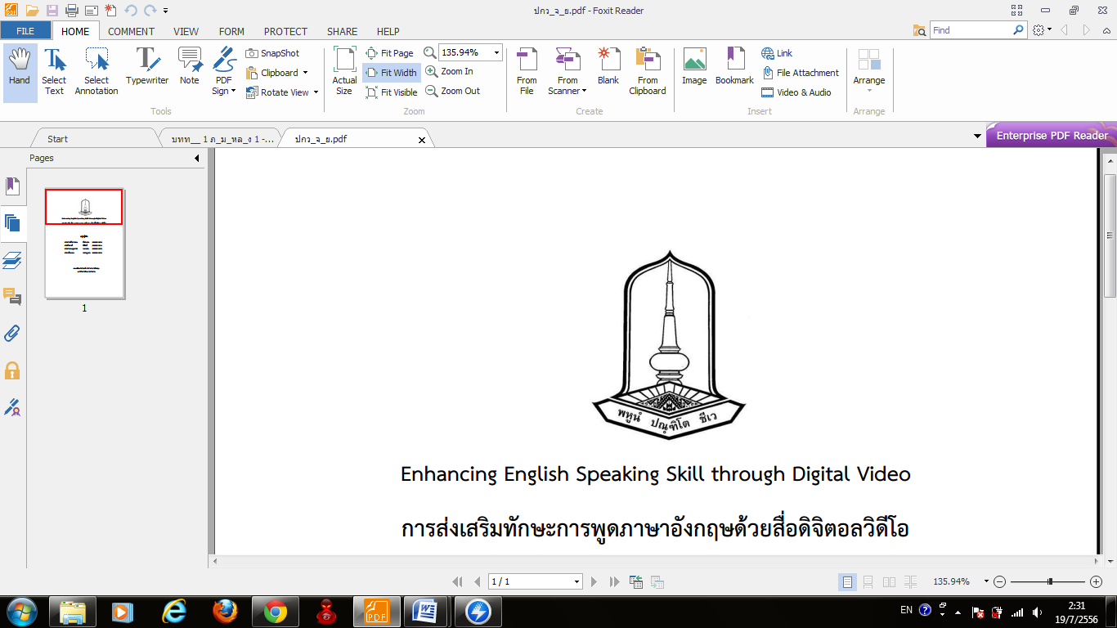

READING MODULE LESSON PLAN

1. Mr. Thitiphong Kon-ngam (Bell) Student Id. 54010513012

นายฐิติพงษ์ คนงาม รหัสนิสิต ๕๔๐๑๐๕๑๓๐๑๒

2. Mr. Thanawat Sa-nguanchart (Gardner) Student Id. 54010513059

นายธนวรรธก์ สงวนชาติ รหัสนิสิต ๕๔๐๑๐๕๑๓๐๕๙

English Major, Faculty of Education

Mahasarakham University