Reading Plan Format

By

4th year students majoring in English

(Nutsu Nutthaphol Phudensai 54010513044
(Amery) Amolwan Phokan 54010513050

Writing Plan Format

Names: Amery and Nutsu
Length of lesson: 1 hour
Who are the Students (age, nationality, gender, etc)? Young adult students in Thailand age’s 15-18 grade 9-12 mixed gender class
Why are they studying? Learn how to take the foreign travel by the airplane step by step. / Have ability to use the words of time sequence in order to describe anything orderly.
Where/when are they studying? During English language class; in a city school
What is the setting (university, language school, public school, etc.)/time of
day/year/frequency of classes? High school, Monday morning class
What facilities are available (room, desks, seating)? Medium private classroom, computer with internet, projector, and whiteboard
What is the main skill area(s)? Reading, Writing and Speaking
What is their ACTFL (English level: beginner, intermediate…etc)? Intermediate
What is the theme? Travel around the world/ Air traveling

Materials: Computer with power point presentation, Video about the air travel to motivate students as a visual material. Real reading text from the airline column http://traveltips.usatoday.com/step-by-step-first-time-air-travel-guide-12490.html (Step-by-Step First-Time Air Travel Guide by Elizabeth Smith) --> papered, Passport, Boarding pass, Airline tickets, speakers, worksheets, T/F worksheets, Ordering worksheets, Example task of post 2 activity.

Objective(s): By the end of the lesson, Students will be able to…. (SWBAT)
- Students will understand to take the foreign travel by the airplane step by step.
- Students will have ability to use the words of time sequence in order to describe something orderly.

I assume the students already know: Some of the vocabulary needed to understand the reading text.

I anticipate students will have problems with: Some of them do not have any experience in traveling aboard by airplane. / And having some problems in using the words of time sequence in order to describe something orderly.

To solve/avoid these problems I plan to: Tell them about teacher’s real experience about traveling aboard by airplane. Moreover, teacher will show them the authentic materials about the air travel like passport, boarding pass and airline tickets. / Teach them how to use the time sequence words to describe something orderly.

How will I assess the students? Collecting the pieces of work to assess and monitoring and giving feedback after the presentation.
Time | Lesson Stage* | Procedure/Steps  Describe so that someone unfamiliar with the lesson could teach it.  (This can be divided into 2 columns: What does the T. do? What do the students do? | Beliefs underlying your choices** | Materials and Aids
20 min. | PRE  - motivation  -prediction  -pre-teach vocab.  - teach structure | 1. Teacher tells his/her experience about traveling aboard by airplane.  Then show them the authentic materials about the air travel like passport, boarding pass and airline tickets. It’s doesn’t matter if teacher doesn’t have any experience, teacher can tell the other people story instead.  It will be better if teacher can show students some videos about the air travel because learning by visual will make students understand what’s happening in the real situation.  2. Ask students to make predictions about the air traveling:  - “Where was your last destination”  - “Where/How can we do the passport?”  - “How many steps in traveling by the airplane?”  3. Elicit vocabulary using the pictures:  Target vocabularies: terminal, immigration, security, baggage, flight, arrival, departure and landed.  4. Teach them the meaning and how to use the words of time sequence in order to describe anything orderly. Let students do the worksheet to check their understanding.  Example of worksheet:  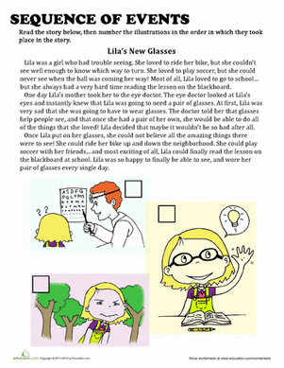 | - Students will know and understand the target vocabulary, and they also have some ideas of air traveling in order to read and understand the text.  - Students will know the meaning and how to use the words of time sequence in order to describe something orderly. This basic knowledge will show off when they read the real text. | Passport, Boarding pass, Airline tickets and Air traveling video  Computer, Projector and  PowerPoint  Computer, Projector,  PowerPoint and  Speaker  Computer, Projector,  PowerPoint and Worksheets
15 min. | During | True or False:  Firstly, teacher teaches students how to scan the text. (3 minutes)  - Individual work.  - Let students read the papered text about 5 minutes. (Scan the text for the specific information.) http://traveltips.usatoday.com/step-by-step-first-time-air-travel-guide-12490.html (Step-by-Step First-Time Air Travel Guide by Elizabeth Smith)  - Let them do the T/F worksheet about the text. (5 minutes)  - Let students do the peers’ check while teacher gives them the answers. (2 minutes)  - Everyone hands in the worksheets to teacher. | -Students are able to read the text by using the scan technique and they will get some ideas about air travel from reading the text. | White board, The papered reading text and  T/F worksheets
15 min.  10 min.  (To describe the homework) | Post 1  Post 2  Homework | Sequence of events:  Before do this activity, teacher have to teach students how to skim the text first. (5 minutes)  - Pair works.  - In 5 minutes, let students read the papered text again. (Skim the whole text in the rush times.)  - Bring the papered text back to teacher.  - Let them do the ordering worksheet about the text. (5 minutes)  - Everyone hands in the worksheets to teacher.  My dream airline:  - Group of three.  - Let the students imagine about if they were the airline owner how they can write the easy/informal paragraph to suggest the new air passengers.  - Hand in the homework in the next class.  - And let them present their works in front of the class.  Example Task:  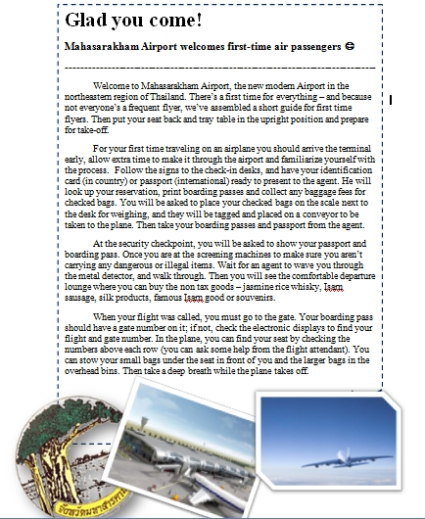 | - Cooperative work with peers.  -Students are able to read the text by using the skim technique.  -Students will get many ideas about air travel from reading the text.  - Students are able to use the words of time sequence in order to describe anything orderly.  - Develop creative thinking, writing and speaking skills.  - Cooperative work with peers.  - Develop creative thinking and writing skills.  - Students have abilities to write an easy/informal paragraph to describe about their dream airline by using the time sequence words.  - Develop the public presentation skill. | White board, The papered reading text and  Ordering worksheets  Example task
*Pre-During-Post: Presentation, Practice, Use

